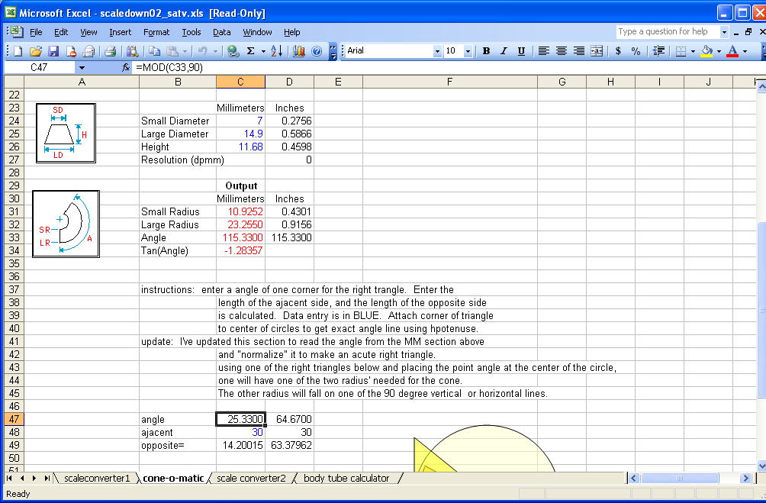

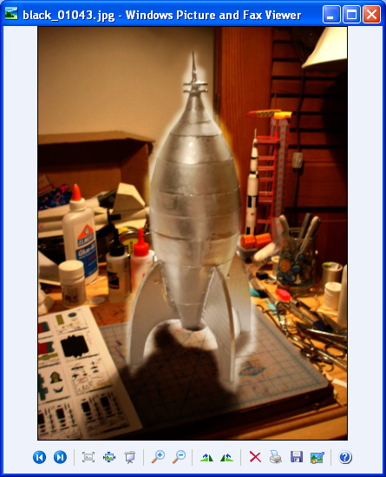

Making the cone from the above numbers.

- Run the numbers in the excel version of cone-o-matic. The bottom section details the shape of the circles and triangles that you need to make the arc-section for the cone.
- In this example the big circle is 23.25mm radius, so for adjacent side of the triangle I picked, 30, the next larger multiple of 10 for the right triangle. The spreadsheet then calculate the opposite side of the triangle to be 14.2 the interior angle being 25.3 which added to 90 will be exactly what was called for, 115 degrees.
- So now I drew a donut shape (the donut has an inner circle that you can conveniently shrink down to get to the center of the circle) and adjusted the size of the circle to double the radius, 46.5mm x 46.5 mm to get the big circle.
- I did the same thing for the small circle, only using the size 21.8mmx21.8, and then made sure that the little center circle of both donuts were on top of each other (both centered on the same point.)
- I then drew any old rectangle putting the corner of the rectangle on that same center point. That angle inside the circles is 90 degrees,
- I then using the right triangle shape drew the right triangle with width 30mm and height 14.2 just like the spread sheet said I need to make the triangle with the balance of the 115 degrees. (25.3)
- Put the triangle point on the center of the circles and then you’ve got your arc for the cone.

8) I then to show you used the freeform line tool to highlight the arc in 50% transparent grey. Normally I would just do this in the gimp program.
9) The rocket above was designed this exact way.

